FAST-NUCES

Director

Dr Shahzad Sarfraz
Professor
Ph D (CS), AIT, Thailand (2012) PhD Approved Supervisor
MSc (CS), University of Agriculture, Faisalabad (2006) BCS, University of the Punjab (2004)
Faculty& Campuses
Multan Campus


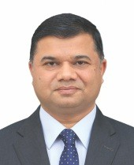
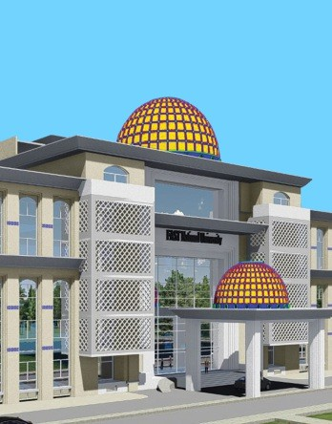
Located in the prestigious DHA area, the up com ing FAST-NUCES Multan Campus is set to become a hub of a c a d e m i c e x c e I I e n c e a n d te ch n o logi cal in n ovdti o n. O n ce completed, it will carry forward the U n i v e rs i ty's pro u d ie g a c y o f c u lti vat i n g b ot h p role s s i o n al competence and personal growth among its students. Our graduates are co nsiste ntly recognized and highly sought after by industries at local, n ation al, and international levels.
As future pioneers of M ultan's emerging tech landscape, we are committed to driving transformative ch ange in the regio n's d igital ecosystem.
Known as the “City of Saints,” Multan is steeped in rich cultural and historical heritage. Coupled with South Punjab's vi b ra nt tra d itio ns and growi ng economic potential, the region offers a u n i q ue setti ng fo r aca d e m i c advancement. The Multan Campus
w i II offe r c utti n g- e d ge d egre e programs in Artificial I ntelligence, Comp uter Scie nce, and Software Engineering starting Fall 2025. Its a r c h i I e c t u r a I d e s i g n w i I I h arm on io us ty b ie nd trad itio n al a e s t h e t i c s w i I h m o d e r n infrastructure, reflecting the spirit of Multan and South Punjab.

P ro s pe ctive st u d e n ts ca n lo o k fo r w a r d t o a n i n t e I I e c t u a I I y ski m u latin g e nviro nm e n t a nd a v i b ra n t c a m p u s I i Ie. P la n n e d a m e n i t i e s i n c I u d e h i g h - t e c h laboratories, modern classrooms, and comfortable residential hostels. O ur pdssio n ate and experienced id C U lty w i II u p h o Id th e high est academic standards, nurturing the innovators and leaders of tomorrow.

The FAST-NUCES Multan Campus is more than just an educational institution-it is poised to become a symbol of progress, innovdtion, and cultural pride for the entire region.
Programs offered at
Multan Campus:

BS(Artificial Intelligence) BS(Computer Science) BS(Software Engineering)

Prospectus 2025

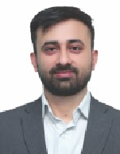
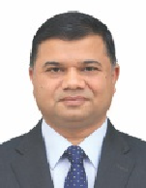
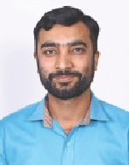
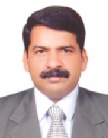
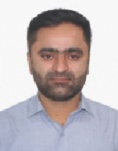
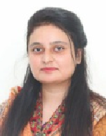
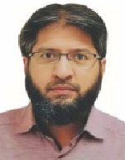
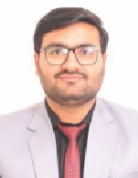

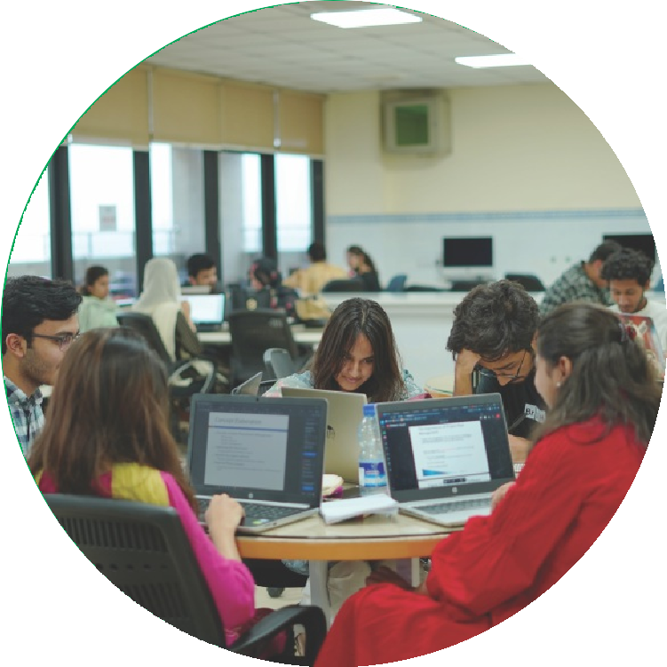
Department of Computer Science

Dr. Shahzad Sarfraz
Professor, Director and HOD (CS)
Ph D DCs), Asian Institute of Tech nology, Bangkok,
Th a i tdnd (2012)
PhD Approved Supervisor
MSc (CS), University of Agricu lture, Fdisalabad (2006) BCS, University of Punjdb (2004)
Dr. Hassan Raza
Assistant Professo r
Ph D (CS), N UCES, IslãMdbdd (2024) OS (CS), N UCES, ISfdMã bad (2018) BS (CS), CO fT!Sdt5, Ve hdri (2015)
Dr. Muhammad Usman
Assistant Professor
Ph D (CS), N UCES, Chiniot- Faisa fabad (2024) MS (CS), N UCES, Chiniot- Faisatabad (2019) BS (CS) N UCES, Chiniot- Faisa tabad (2016)
Mr. Nouman lftikhar
Assistant Professo r
MPhif (Eng.), RI U, Isfam abdd (2021) MBA, Abu D habi U nive rsity, UAE (2010) MA (Eng.), BZU, Multdn (2001)

Mr. Muhammad Shoaib
Lecturer
US (Mdth), N UCES, La ho re (2019)
BS (Path), University of Sargod ha, La hore (2017)

Prospectus 2025

F A S T — N U C E S
Faculty-Multan

Mr. Habib Ali Katohar
Lecturer
Mp his (Pakistan Stud.), QAU, ISOa Mdbad (2021) MSc (Def. & Strat. Stud.), QAU, Islamabad (2018) BSc (Pub lie Ad m.) SALU, Khairpur (2013)
Ms. Kashaf Shakoor
Lecturer
MS (CS), N UCES, Chiniot- Faisa ldbad (2023) BS (CS), N FCIET, Mu Stan (2021)
Mr. Ahmad Ali Tabassam
Lecturer
MS (IT), OWL University of Applied Sciences and Arts Lemgo, Germany (2007)
BS (CS), BZU, Mu Stan (2002)
Ms. Farwa Ahmad
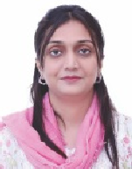
Lecturer
MS (CS), NUCES, Chiniot- Faisalabad (2020)
BS (CS), N UCES, Chi niot- Faisa ldbad (2017)

